**M.Nilofer Sultana,**

**AP17110010058, CSE-01.**

**Implementing OR using Adaline**

In [246]: **import** matplotlib.pyplot **as** plt **import** numpy **as** np b**=**0.45 x0**=**[1,1,1,1] x1**=**[1,1,**-**1,**-**1] x2**=**[1,**-**1,1,**-**1] t **=**[1,1,1,**-**1]

w **=** 2**\***np.random.random((3,1)) **-** 1

print(w) y**=**[0,0,0,0] y_out**=**[0,0,0,0] er**=**[] **for** j **in** range (3): print("epoch",j**+**1) **for** i **in** range(4):

x**=**(x0[i]**\***w[0])**+**(x1[i]**\***w[1])**+**(x2[i]**\***w[2])

y[i]**=**x **if** (y[i]**>=**0): y_out[i]**=**1 **else**:

## y_out[i]**=-**1

dif**=**t[i]**-**x er.append(dif) **if** (y_out[i]**!=**t[i]):

w[0]**=**w[0]**+**(b**\***dif**\***x0[i]) w[1]**=**w[1]**+**(b**\***dif**\***x1[i]) w[2]**=**w[2]**+**(b**\***dif**\***x2[i])

print(w) **for** i **in** range(4):

x**=**(x0[i]**\***w[0])**+**(x1[i]**\***w[1])**+**(x2[i]**\***w[2])

y[i]**=**x **if** (x**>**0):

y_out[i]**=**1 **else**:

y_out[i]**=-**1

print("Acutal ",y_out,"Desired ",t)

ax **=** plt.subplot(111)

ax.plot(er, c**=**"#aaaaff", label**=**"Training Errors")

ax.set_xscale("log") plt.title("ADALINE Errors (2,-2)")

[[0.50028863]

[0.97772218]

[0.49633131]]

plt

.

title

(

"ADALINE Errors (2,-2)"

)

plt

.

legend

()

plt

.

xlabel

(

"Error"

)

plt

.

ylabel

(

"Value"

)

plt

.

show

()

# epoch 1

Acutal [1, 1, 1, -1] Desired [1, 1, 1, -1]

# epoch 2

Acutal [1, 1, 1, -1] Desired [1, 1, 1, -1]

# epoch 3

# Acutal [1, 1, 1, -1] Desired [1, 1, 1, -1]

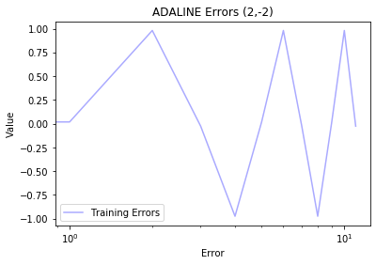

**Implementing AND using Adaline**

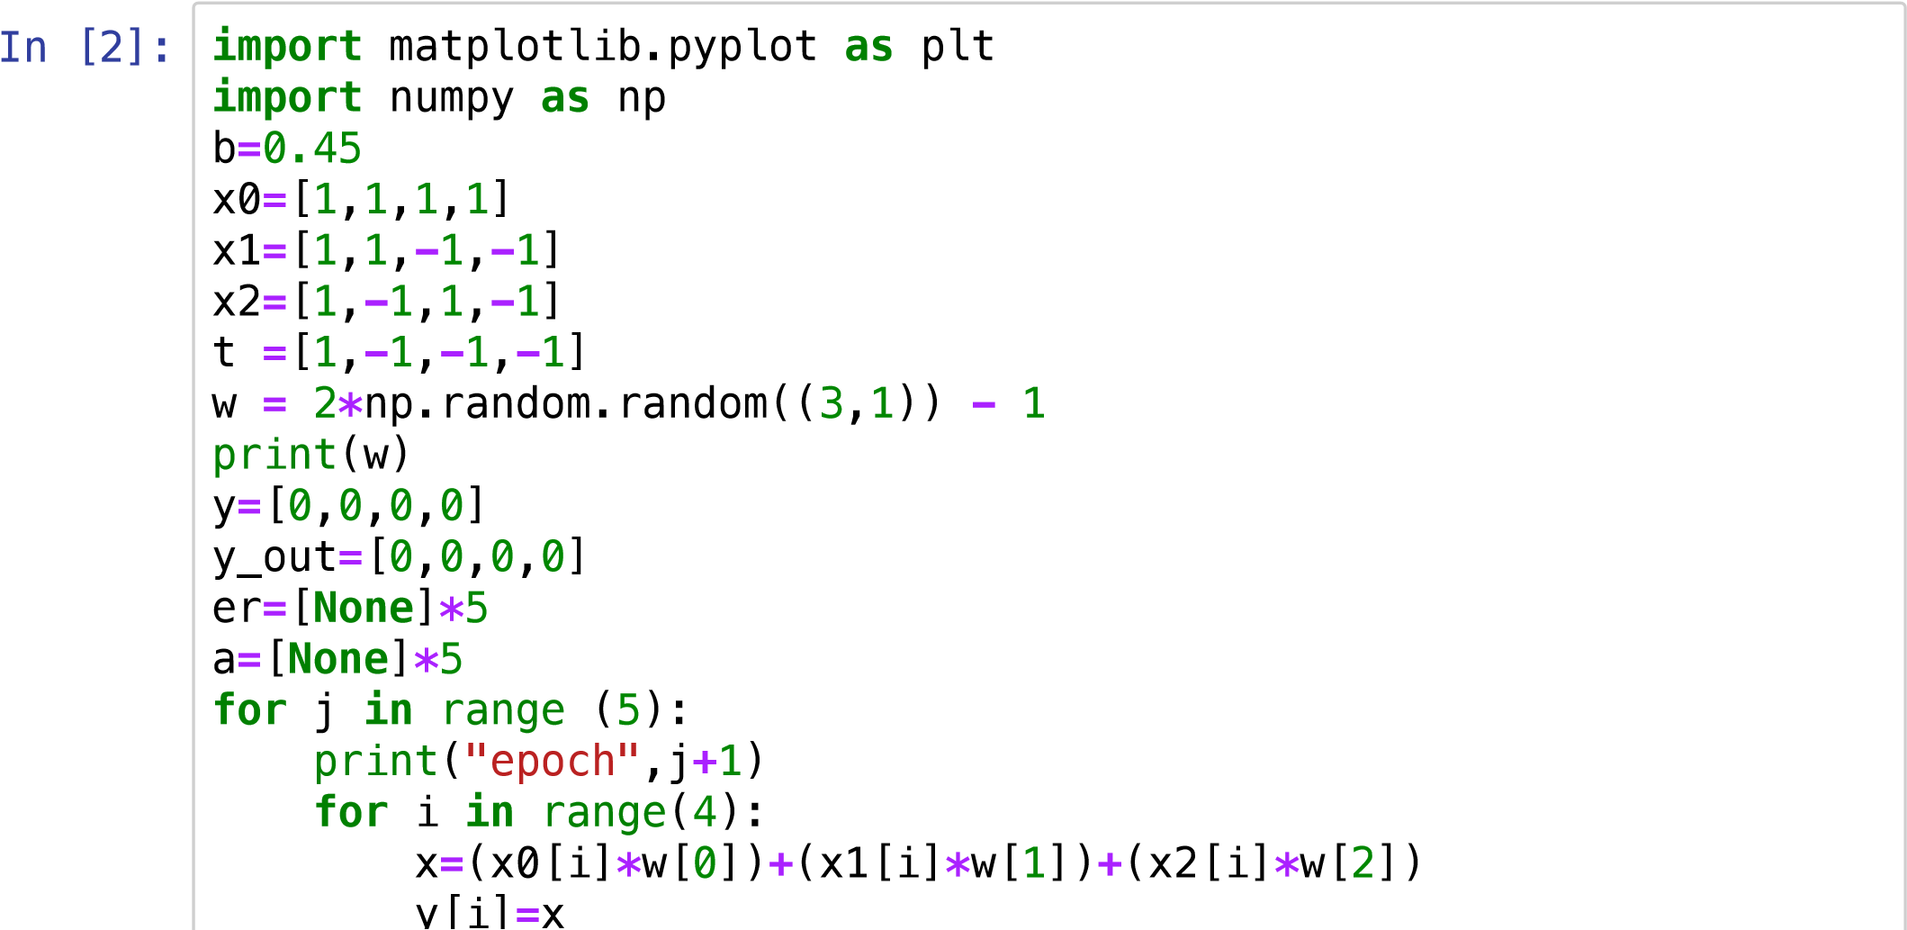

y[i]**=**x **if** (y[i]**>=**0): y_out[i]**=**1 **else**: y_out[i]**=-**1 dif**=**t[i]**-**x er[i]**=**dif **if** (y_out[i]**!=**t[i]):

w[0]**=**w[0]**+**(b**\***dif**\***x0[i]) w[1]**=**w[1]**+**(b**\***dif**\***x1[i]) w[2]**=**w[2]**+**(b**\***dif**\***x2[i])

print(w) **for** i **in** range(4):

x**=**(x0[i]**\***w[0])**+**(x1[i]**\***w[1])**+**(x2[i]**\***w[2])

y[i]**=**x **if** (x**>**0): y_out[i]**=**1 **else**: y_out[i]**=-**1 print("Acutal ",y_out,"Desired ",t)

ax **=** plt.subplot(111)

ax.plot(er,c**=**"#00ff00",label**=**'Training errors')

ax.set_xscale("log") plt.legend() plt.show()

[[ 0.90831597]

[-0.66003107]

[ 0.29098966]] epoch 1 [[-0.37838554]

[ 0.62667045]

[-0.99571186]]

Acutal [-1, 1, -1, -1] Desired [1, -1, -1, -1]

epoch 2

[[ 0.40795659]

[ 1.41301258]

[-0.20936973]]

[[-0.95569591]

[ 0.04936007]

[ 1.15428277]]

[[-1.47284797]

[ 0.56651213]

[ 0.63713072]]

Acutal [-1, -1, -1, -1] Desired [1, -1, -1, -1]

epoch 3

[[-0.90170566]

[ 1.13765443]

[ 1.20827302]]

Acutal [1, -1, -1, -1] Desired [1, -1, -1, -1]

epoch 4

Acutal [1, -1, -1, -1] Desired [1, -1, -1, -1]

epoch 5

# Acutal [1, -1, -1, -1] Desired [1, -1, -1, -1]

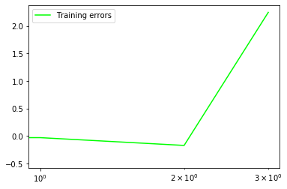

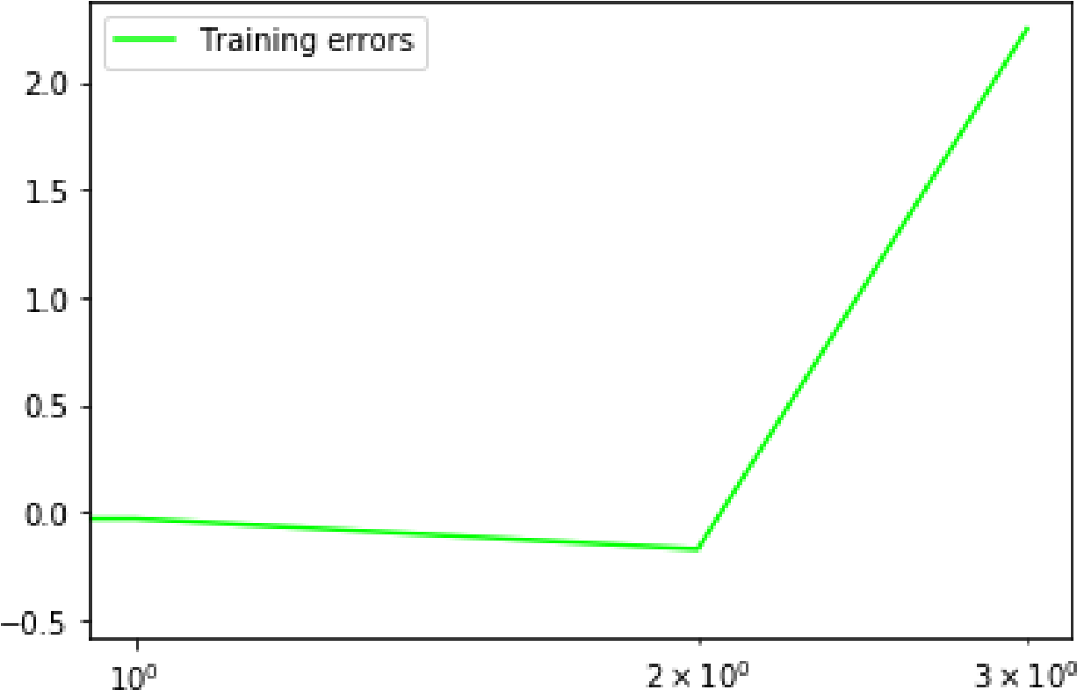

**Implementing XOR using Adaline**

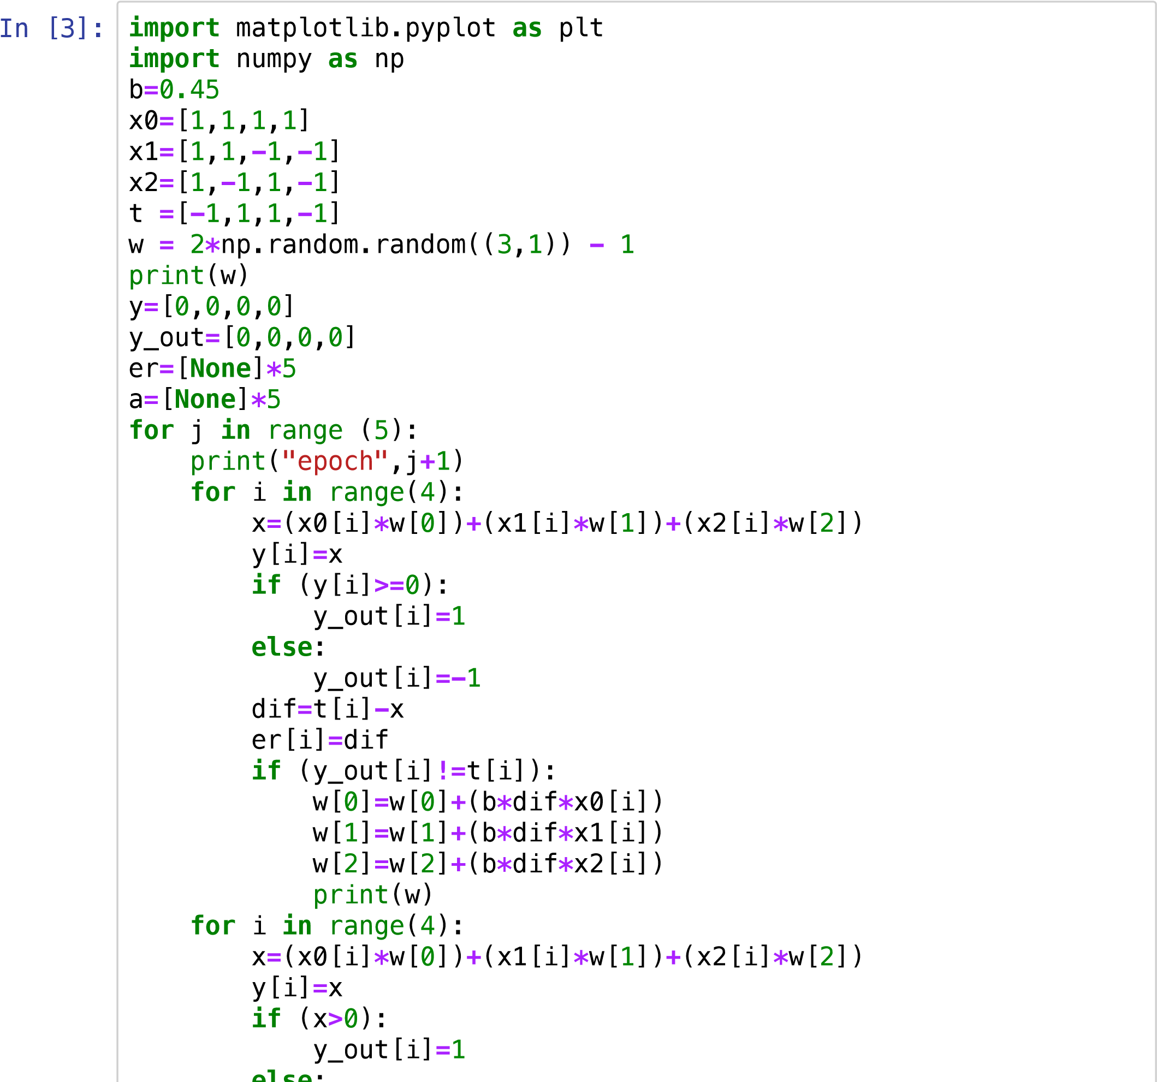

**else**:

y_out[i]**=-**1 print("Acutal ",y_out,"Desired ",t)

ax **=** plt.subplot(111)

ax.plot(er,c**=**"#00ff00",label**=**'Training errors')

ax.set_xscale("log") plt.legend() plt.show()

[[ 0.97281281]

[-0.63229226]

[-0.55900287]] epoch 1 [[-0.45103576]

[ 0.79155632]

[ 0.8648457 ]]

Acutal [1, -1, -1, -1] Desired [-1, 1, 1, -1]

epoch 2

[[-1.44345058]

[-0.2008585 ]

[-0.12756912]]

[[-0.31091759]

[ 0.93167448]

[-1.2601021 ]]

[[ 1.26529478]

[-0.6445379 ]

[ 0.31611028]]

[[0.0981197 ]

[0.52263718]

[1.48328536]]

Acutal [1, -1, 1, -1] Desired [-1, 1, 1, -1]

epoch 3 [[-1.29869931]

[-0.87418183]

[ 0.08646635]]

[[ 0.16800706]

[ 0.59252454]

[-1.38024002]]

[[ 1.43014793]

[-0.66961633]

[-0.11809915]]

[[-0.0178906 ]

[ 0.7784222 ]

[ 1.32993939]]

Acutal [1, -1, 1, -1] Desired [-1, 1, 1, -1]

epoch 4 [[-1.40860255]

[-0.61228974]

[-0.06077255]]

[[-0.07654867]

[ 0.71976414]

[-1.39282644]]

[[ 1.35856399]

[-0.71534852]

[ 0.04228622]]

[[-0.00566784]

[ 0.64888331]

[ 1.40651805]]

Acutal [1, -1, 1, -1] Desired [-1, 1, 1, -1]

epoch 5 [[-1.37804792]

[-0.72349678]

[ 0.03413797]]

[[ 0.03300928]

[ 0.68756042]

[-1.37691923]]

[[ 1.39717095]

[-0.67660125]

[-0.01275756]]

[[0.00823256]

[0.71233714]

[1.37618083]]

Acutal [1, -1, 1, -1] Desired [-1, 1, 1, -1]

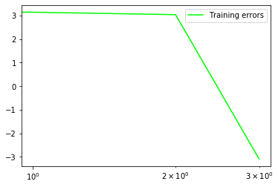

**Implementing XOR using Madaline**

In

[23]:

**import**

numpy

**as**

np

**import**

matplotlib

.

pyplot

**as**

plt

*#np.random.seed(0)*

**def**

sigmoid

(

x

):

**return**

1

**/**

(

1

**+**

np

.

exp

(

**-**

x

))

**def**

sigmoid_derivative

(

x

):

**return**

x

**\***

(

1

**-**

x

)

*#Input datasets*

inputs

**=**

np

.

array

([[

0

,

0

]

,

[

0

,

1

]

,

[

1

,

0

]

,

[

1

,

1

]])

target

**=**

np

.

array

([[

0

]

,

[

1

]

,

[

1

]

,

[

0

]])

epochs

**=**

10000

epochs **=** 10000 lr **=** 0.1 er**=**[]

inputLayerNeurons, hiddenLayerNeurons, outputLayerNeurons **=** 2,2,1

*#Random weights and bias initialization*

hidden_weights **=** np.random.uniform(size**=**(inputLayerNeurons,hiddenLa hidden_bias **=**np.random.uniform(size**=**(1,hiddenLayerNeurons)) output_weights **=** np.random.uniform(size**=**(hiddenLayerNeurons,outputL output_bias **=** np.random.uniform(size**=**(1,outputLayerNeurons))

print("Initial hidden weights: ",end**=**'')

print(**\***hidden_weights)

print("Initial hidden biases: ",end**=**'')

print(**\***hidden_bias)

print("Initial output weights: ",end**=**'')

print(**\***output_weights)

print("Initial output biases: ",end**=**'')

print(**\***output_bias)

*#Training algorithm* **for** _ **in** range(epochs): *#Forward Propagation*

hidden_layer_activation **=** np.dot(inputs,hidden_weights)

hidden_layer_activation **+=** hidden_bias

hidden_layer_output **=** sigmoid(hidden_layer_activation)

output_layer_activation **=** np.dot(hidden_layer_output,output_wei

output_layer_activation **+=** output_bias

predicted_output **=** sigmoid(output_layer_activation)

*#Backpropagation*

error **=** target **-** predicted_output er.append(error)

d_predicted_output **=** error **\*** sigmoid_derivative(predicted_outpu error_hidden_layer **=** d_predicted_output.dot(output_weights.T) d_hidden_layer **=** error_hidden_layer **\*** sigmoid_derivative(hidden

*#Updating Weights and Biases*

output_weights **+=** hidden_layer_output.T.dot(d_predicted_output) output_bias **+=** np.sum(d_predicted_output,axis**=**0,keepdims**=True**)

hidden_weights **+=** inputs.T.dot(d_hidden_layer) **\*** lr

hidden_bias **+=** np.sum(d_hidden_layer,axis**=**0,keepdims**=True**) **\*** lr

print("Final hidden weights: ",end**=**'')

print(**\***hidden_weights) print("Final hidden bias: ",end**=**'')

print(**\***hidden_bias)

print("Final output weights: ",end**=**'')

print(**\***output_weights) print("Final output bias: ",end**=**'')

print(**\***output_bias)

print("\nOutput from neural network after 10,000 epochs: ",end**=**'') print("\nOutput from neural network after 10,000 epochs: ",end**=**'')

print

(

**\***

predicted_output

)

ax

**=**

plt

.

subplot

(

111

)

x_line

**=**

np

.

linspace

(

0

,

1

)

plt

.

plot

(

error

)

plt

.

xlabel

(

"Epochs"

)

plt

.

ylabel

(

"Error"

)

plt

.

show

()

Initial hidden weights: [0.02286355 0.86046719] [0.283145 0.5667 9159]

Initial hidden biases: [0.66192064 0.77672574]

Initial output weights: [0.7822206] [0.09087432]

Initial output biases: [0.48715264] Final hidden weights: [3.48503873 5.69065929] [3.4885271 5.709948 55]

Final hidden bias: [-5.32273513 -2.31108219] Final output weights: [-7.69490057] [7.10716369]

Final output bias: [-3.18254136]

Output from neural network after 10,000 epochs: [0.0705266] [0.933

06776] [0.93299628] [0.07364187]

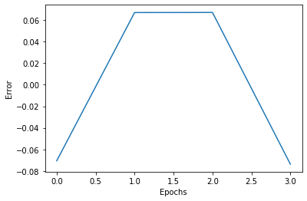

**Feed forward error back propagation learning for iris dataset**

In [3]: **from** matplotlib **import** pyplot **as** plt **import** pandas **as** pd **import** numpy **as** np **from** sklearn **import** datasets iris **=** datasets.load_iris()

iris.loc[iris["Name"]**==**"virginica","species"]**=**0 iris.loc[iris["Name"]**==**"versicolor","species"]**=**1 iris.loc[iris["Name"]**==**"setosa","species"] **=** 2

iris **=** iris[iris["species"]**!=**2]

1. **=** iris[["PetalLength", "PetalWidth"]].values.T
2. **=** iris[["species"]].values.T

Y **=** iris[["species"]].values.T

Y **=** Y.astype("uint8")

plt.scatter(X[0, :], X[1, :], c**=**Y[0,:], s**=**40, cmap**=**plt.cm.Spectral) plt.title("IRIS DATA | Blue - Versicolor, Red - Virginica ")

plt.xlabel("Petal Length") plt.ylabel("Petal Width")

plt.show() **def** old_para(n_x, n_h, n_y):

np.random.seed(2)

W1 **=** np.random.randn(n_h, n_x) **\*** 0.01 b1 **=** np.zeros(shape**=**(n_h, 1)) W2 **=** np.random.randn(n_y, n_h) **\*** 0.01 b2 **=** np.zeros(shape**=**(n_y, 1)) parameters **=** {"W1": W1,

"b1": b1,

"W2": W2, "b2": b2} **return** parameters **def** size(X, Y):

n_x **=** X.shape[0] n_h **=** 6 n_y **=** Y.shape[0] **return** (n_x, n_h, n_y) **def** forward_propagation(X, parameters):

W1 **=** parameters["W1"] b1 **=** parameters["b1"] W2 **=** parameters["W2"] b2 **=** parameters["b2"] Z1 **=** np.dot(W1, X) **+** b1

A1 **=** np.tanh(Z1)

Z2 **=** np.dot(W2, A1) **+** b2

A2 **=** 1**/**(1**+**np.exp(**-**Z2)) cache **=** {"Z1": Z1,

"A1": A1,

"Z2": Z2, "A2": A2} **return** A2, cache **def** computingcost(A2, Y, parameters):

m **=** Y.shape[1]

W1 **=** parameters["W1"] W2 **=** parameters["W2"]

logprobs **=** np.multiply(np.log(A2), Y) **+** np.multiply((1 **-** Y), np

cost **=** **-** np.sum(logprobs) **/** m

**return** cost **def** backward_propagation(parameters, cache, X, Y):

m **=** X.shape[1]

W1 **=** parameters["W1"]

W2 **=** parameters["W2"]

A1 **=** cache["A1"] A2 **=** cache["A2"] dZ2**=** A2 **-** Y

cW2 **=** (1 **/** m) **\*** np.dot(dZ2, A1.T)

cb2 **=** (1 **/** m) **\*** np.sum(dZ2, axis**=**1, keepdims**=True**) dZ1 **=** np.multiply(np.dot(W2.T, dZ2), 1 **-** np.power(A1, 2))

cW1 **=** (1 **/** m) **\*** np.dot(dZ1, X.T)

cW1 **=** (1 **/** m) **\*** np.dot(dZ1, X.T)

cb1 **=** (1 **/** m) **\*** np.sum(dZ1, axis**=**1, keepdims**=True**)

grads **=** {"cW1": cW1,

"cb1": cb1,

"cW2": cW2, "cb2": cb2} **return** grads **def** new_para(parameters, grads, lr**=**1.2):

W1 **=** parameters["W1"] b1 **=** parameters["b1"] W2 **=** parameters["W2"] b2 **=** parameters["b2"] cW1 **=** grads["cW1"] cb1 **=** grads["cb1"] cW2 **=** grads["cW2"] cb2 **=** grads["cb2"] W1 **=** W1 **-** lr **\*** cW1 b1 **=** b1 **-** lr **\*** cb1 W2 **=** W2 **-** lr **\*** cW2 b2 **=** b2 **-** lr **\*** cb2 parameters **=** {"W1": W1,

"b1": b1,

"W2": W2, "b2": b2} **return** parameters **def** nn_model(X, Y, n_h, epoch**=**10000, print_cost**=False**):

np.random.seed(3) n_x **=** size(X, Y)[0] n_y **=** size(X, Y)[2]

parameters **=** old_para(n_x, n_h, n_y)

W1 **=** parameters["W1"] b1 **=** parameters["b1"] W2 **=** parameters["W2"] b2 **=** parameters["b2"] **for** i **in** range(0, epoch):

A2, cache **=** forward_propagation(X, parameters) cost **=** computingcost(A2, Y, parameters) grads **=** backward_propagation(parameters, cache, X, Y)

parameters **=** new_para(parameters, grads) **if** print_cost **and** i **%** 1000 **==** 0: print ("Cost after iteration %i: %f" **%** (i, cost))

**return** parameters,n_h

parameters **=** nn_model(X,Y , n_h **=** 6, epoch**=**10000, print_cost**=True**) **def** plot_decision_boundary(model, X, y):

x_min, x_max **=** X[0, :].min() **-** 0.25, X[0, :].max() **+** 0.25 y_min, y_max **=** X[1, :].min() **-** 0.25, X[1, :].max() **+** 0.25

h **=** 0.01

xx, yy **=** np.meshgrid(np.arange(x_min, x_max, h), np.arange(y_mi

Z **=** model(np.c_[xx.ravel(), yy.ravel()]) Z **=** Z.reshape(xx.shape)

plt.contourf(xx, yy, Z, cmap**=**plt.cm.Spectral)

plt.ylabel("x2") plt.xlabel("x1")

plt.scatter(X[0, :], X[1, :], c**=**y, cmap**=**plt.cm.Spectral) plot_decision_boundary(**lambda** x: predict(parameters, x.T), X, Y[0,: plot_decision_boundary(**lambda** x: predict(parameters, x.T), X, Y[0,:

plt.title("Boundary for hidden layer size " **+** str(6))

plt.xlabel("Petal Length") plt.ylabel("Petal Width")

In [ ]: